Sample Letters and Emails

Sample fundraising letters are available in your online Participant Center. Use these letters to help draft a variety of messages that you can send through the U.S. Postal Service or via email!

To customize these sample letters and emails
- Look for the RED text
- Update the RED text with the appropriate information for you
- Change the RED text to BLACK

Sample Letters and Emails
Click below to jump to the Sample Letter or Email
- Basic Solicitation
- Informal Solicitation
- Take 10 Letter
- In Honor Of Someone
- In Memory Of Someone
- Sample Email for New or Returning Walkers
- Sample Email Message for Returning Walkers
- Sample Email Message for Follow-Up
- Sample Email Message for Corporate Walkers

Note
To use the Walk to Defeat ALS® logo below in your emails, letters, simply right click to copy and paste!

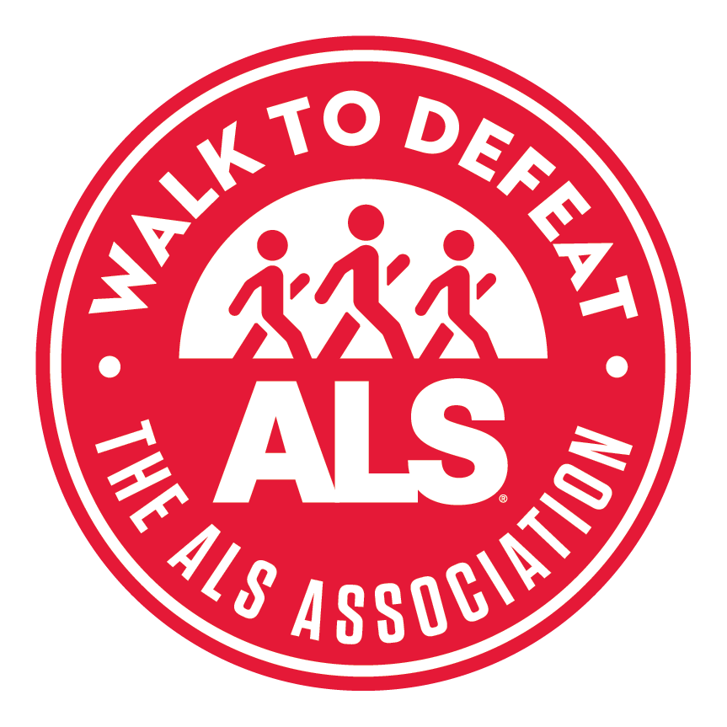

Basic Solicitation

Name
Address
City, State, Zip
Dear Name,
On (insert date here), I'm joining hundreds of participants for The ALS Association’s Rocky Mountain Chapter Walk to Defeat ALS® at (insert location here), and I need your help to make my efforts matter! With your help, we can make a difference for people living with ALS and take steps toward a cure.
ALS affects the motor neurons in a person's brain and spinal cord. When the motor neurons die, the muscles waste away. Gradually, a person is robbed of the ability to walk, speak, eat, and eventually breathe. All the while, the mind remains sharp. Upon diagnosis, doctors give ALS patients only two to five years to live. Currently, there is no known cause or cure for ALS.
And that's why I’m walking – for those who can’t. I’m walking to help The ALS Association fund vital care services programs in our community – including support groups, medical equipment loans, respite care, and specialist consultation. I’m walking to support cutting-edge research across the world in promising labs carefully selected by The ALS Association. I’m walking to be a voice for those living with ALS and their families on Capitol Hill by urging our representatives to support legislation and funding that enhances quality of life. I’m walking to join the movement for a cure.
My personal fundraising goal is $(insert goal here). I hope you’ll join the movement, too, and help me reach it.
By making a one-time, tax-deductible donation, you can truly make a difference in the fight against ALS. Please visit my online fundraising website at (insert website here) to make a donation, or send your contribution to me at (insert your name, Address, City, State, Zip). You can also mail it straight to The ALS Association Rocky Mountain Chapter at 10855 Dover St., Ste. 500 Westminster, CO 80021 and include a note that it should be credited to (insert Walk team name). Checks can be made payable to The ALS Association Rocky Mountain Chapter.
Any amount you feel comfortable giving is deeply appreciated. After all, every dollar counts! Thank you for helping create a world without ALS.
Sincerely,
Name
P.S. Your employer may have a matching gift policy. If so, you can easily double or triple your pledge. Just send in your company's matching gift form along with your check. Check out www.matchinggifts.com/als to see whether your company participates.

Informal Solicitation

Hello Friends and Family!

The ALS Association’s Rocky Mountain Chapter Walk to Defeat ALS® is coming up very soon. And that means it’s fundraising time again.

As you know, this is a cause near and dear to my heart because (insert reason for walking here). I hope you’ll take some time to consider a few reasons you should join the movement to cure ALS today!

- When a person is diagnosed with ALS, the motor neurons in the brain and spinal cord begin to die. Gradually, a person is robbed of the ability to walk, speak, eat, and eventually breathe. All the while, the mind remains sharp. Upon diagnosis, doctors give ALS patients only two to five years to live.
- More than 5,000 people are newly diagnosed with ALS each year. Currently, there is no known cause or cure, and only two treatments (which modestly extend life) available. Did you know that the costs to care for someone living with ALS can be nearly $250,000 per year? The Walk to Defeat ALS funds local care services to help alleviate that cost, as well as cutting-edge research in the search for a cause and cure.
- Your donation can earn you a tax break! 100 percent of your donation to The ALS Association Rocky Mountain Chapter is tax-deductible.
I am asking for your financial support in my pursuit to raise (insert personal fundraising goal) for The ALS Association Rocky Mountain Chapter through the Walk to Defeat ALS.

Please click on the link below to go directly to my personal fundraising page and join the movement today! (insert web address to participant center)

If you would rather send a check, please mail it to:

Your Information Here | or | The ALS Association Rocky Mountain Chapter  10855 Dover St., Ste. 500  Westminster, CO 80021

Make your check payable to The ALS Association Rocky Mountain Chapter, and make sure you include a note with my name on it!

Name
P.S. I would appreciate it if you would forward this email to as many people as you can to encourage them to donate as well!
P.P.S. Your employer may have a matching gift policy. If so, you can easily double or triple your pledge. Just send in your company's matching gift form with your check. Check out www.matchinggifts.com/als to see whether your company participates.
Take 10 Letter

This letter is designed to be sent out by friends and family to help expand your reach. Have them send it to their network of contacts!

Hi guys –

My sister, Jane, is participating in the Walk to Defeat ALS® and raising money to help local families living with ALS. This is her first time (or her fifth, etc), and she could use some help. So I am asking you to Take 10!

Take 10 minutes … maybe less!
- Go to Jane's website, (insert participant page), and read about what she is doing. ALS affects more than 20,000 people in the United States alone, and currently there is no known cause or cure.

Take 10 bucks … and give it away!
- Donate online: Did you know that just $10 can help purchase an adaptive set of utensils for someone living with ALS? Imagine the impact your gift of $10 (or more, if you’d like) can make!

Take 10 friends … and press send!
- Send this to ten friends and help spread the word. Share her story on your social media networks and help raise awareness about this rare but always fatal disease. You never know who may have a connection!

About The ALS Association Rocky Mountain Chapter
The ALS Association is the only nonprofit organization fighting Lou Gehrig’s Disease on every front. By leading the way in global research, providing assistance for people with ALS through a nationwide network of chapters, coordinating multidisciplinary care through certified clinical care centers, and fostering government partnerships, the Association builds hope and enhances quality of life while aggressively searching for new treatments and a cure.

In Honor Of

Dear Friends and Family,

If you are reading this letter, you know that my mom has not had an easy fight against ALS. Diagnosed 2 years ago, she is now dependent on others for all aspects of her daily care. Despite all that ALS has taken from her, she has managed to keep her sense of humor and displays an unbelievable ability to turn lemons into lemonade. She has taught us all something about perseverance and determination.

I’ll need both qualities as I tackle an upcoming fundraising event for The ALS Association Rocky Mountain Chapter – the Walk to Defeat ALS®. People living with ALS face far greater challenges than the short walk I am about to take. I walk for my mom and for all those living with ALS who can’t walk at all, so that in the future, no one will ever hear the words, “You have ALS.”

Last year, with your help, I raised over $3,000 for The ALS Association Rocky Mountain Chapter. Thank you again for your generosity. This year, I am hoping to raise (insert fundraising goal). This fundraising effort is not just about the money, it’s about the people, the research, the care, and the cure.

Please consider sponsoring me again by making a tax-deductible donation to The ALS Association Rocky Mountain Chapter as they work toward their ultimate vision – a world without ALS. You can easily make an online donation at (www.your participant-center-link.com). Every donation will bring me closer to my goal of (insert fundraising goal). If you would prefer to send a check, you can mail it to my home address (insert address) or the Chapter office – The ALS Association Rocky Mountain Chapter 10855 Dover St., Ste. 500 Westminster, CO 80021. I would like to receive every donation by (date) (although they are always accepted)!

Thank you for joining the movement to cure ALS. If you have any questions please give me a call or send me an email (phone number, email address). I also love referrals – if you know someone who would be interested in making a donation, please send them a note with my letter. Together, we can defeat ALS.

Sincerely,

Your name

About The ALS Association
The ALS Association is the only nonprofit organization fighting Lou Gehrig’s Disease on every front. By leading the way in global research, providing assistance for people with ALS through a nationwide network of chapters, coordinating multidisciplinary care through certified clinical care centers, and fostering government partnerships, the Association builds hope and enhances quality of life while aggressively searching for new treatments and a cure.

In Memory Of

Dear Friends and Family,

If you are reading this letter, you know that my mom did not have an easy fight against ALS. She was diagnosed three years ago and was taken too soon, on January 15, 2010. Despite all that ALS had taken from her, she somehow managed to keep her sense of humor and displayed an unbelievable ability to turn lemons into lemonade. She taught us all something about perseverance and determination.

I’ll need both qualities as I tackle an upcoming fundraising event for The ALS Association Rocky Mountain Chapter – the Walk to Defeat ALS®. People living with ALS face far greater challenges than the short walk I am about to take. So I walk in memory of my mom, and for all those we’ve lost or those currently living with this disease. By joining the movement to cure ALS, we can ensure that no one ever has to hear the words -- “You have ALS” -- again.

Last year, with your help, I raised over $3,000 for The ALS Association Rocky Mountain Chapter. Thank you again for your generosity. This year, I am hoping to raise (insert fundraising goal). This fundraising effort is not just about the money, it’s about the people, the research, the care, and the cure.

Please consider sponsoring me again by making a tax-deductible donation to The ALS Association Rocky Mountain Chapter as they work toward their ultimate vision – a world without ALS. You can easily make an online donation at (www.your participant-center-link.com). Every donation will bring me closer to my goal of (insert fundraising goal). If you would prefer to send a check, you can mail it to my home address (insert address) or the Chapter office – The ALS Association Rocky Mountain Chapter 10855 Dover St., Ste. 500 Westminster, CO 80021. I would like to receive every donation by (date) (although they are always accepted)!

Thank you for joining the movement to cure ALS. If you have any questions please give me a call or send me an email (phone number, email address). I also love referrals – if you know someone who would be interested in making a donation, please send them a note with my letter. Together we can defeat ALS.

Sincerely,

Your name

About The ALS Association
The ALS Association is the only nonprofit organization fighting Lou Gehrig’s Disease on every front. By leading the way in global research, providing assistance for people with ALS through a nationwide network of chapters, coordinating multidisciplinary care through certified clinical care centers, and fostering government partnerships, the Association builds hope and enhances quality of life while aggressively searching for new treatments and a cure.

Sample Email for New or Returning Walkers
On (insert date here), I'm joining hundreds of participants for The ALS Association’s Rocky Mountain Chapter Walk to Defeat ALS® at (insert location here), and I need your help to make my efforts matter! With your help, we can make a difference for people living with ALS and take steps toward a cure.
ALS affects the motor neurons in a person's brain and spinal cord. When the motor neurons die, the muscles waste away. Gradually, a person is robbed of the ability to walk, speak, eat, and eventually breathe. All the while, the mind remains sharp. Upon diagnosis, doctors give ALS patients only two to five years to live. Currently, there is no known cause or cure for ALS.
And that's why I’m walking – for those who can’t. I’m walking to help The ALS Association Rocky Mountain Chapter fund vital care services programs in our community – including support groups, medical equipment loans, respite care, and specialist consultation. I’m walking to support cutting-edge research across the world in promising labs carefully selected by The ALS Association. I’m walking to be a voice for those living with ALS and their families on Capitol Hill by urging our representatives to support legislation and funding that enhances quality of life. I’m walking to join the movement for a cure.
My personal fundraising goal is $(insert goal here). I hope you’ll join the movement, too, and help me reach it.
By making a one-time, tax-deductible donation, you can truly make a difference in the fight against ALS. Please visit my online fundraising website – (insert website here) – to make a donation, or send your contribution to me at (insert your name, Address, City, State, Zip). You can also mail it straight to The ALS Association Rocky Mountain Chapter 10855 Dover St., Ste. 500 Westminster, CO 80021 and include a note that it should be credited to (insert Walk team name). Checks can be made payable to The ALS Association Rocky Mountain Chapter.
Any amount you feel comfortable giving is deeply appreciated. After all, every dollar counts! Thank you for helping create a world without ALS.
Sincerely,
[Name]
P.S. Please forward this email to as many people as possible and encourage them to donate too!
About The ALS Association
The ALS Association is the only nonprofit organization fighting Lou Gehrig’s Disease on every front. By leading the way in global research, providing assistance for people with ALS through a nationwide network of chapters, coordinating multidisciplinary care through certified clinical care centers, and fostering government partnerships, the Association builds hope and enhances quality of life while aggressively searching for new treatments and a cure.

Sample Email Message for Returning Walkers

As you may know, I’m a loyal participant in The ALS Association’s Rocky Mountain Chapter Walk to Defeat ALS®. I’ve walked in the past and have learned firsthand that the Walk is a life-changing event, uniting thousands of people around the nation to fight for the same ultimate goal – a world without ALS! The Walk is coming up again very soon, and that means it’s fundraising time again.

WAIT!!!!!

Before you dismiss this email – thinking, “Are you really asking me again?” -- I hope you’ll consider a few things.

1. More than 5,000 people are newly diagnosed with ALS each year. Currently, there is no known cause or cure, and only two treatments (which modestly extend life) available. Did you know that the costs to care for someone living with ALS can add up to nearly $250,000 per year? The Walk to Defeat ALS funds local care services to help alleviate that cost, as well as cutting-edge research in the search for a cause and cure.

2. Your donation can earn you a tax break! 100 percent of whatever amount you donate to The ALS Association Rocky Mountain Chapter is tax-deductible.

3. When a person is diagnosed with ALS, the motor neurons in the brain and spinal cord begin to die. Gradually, a person is robbed of the ability to walk, speak, eat, and eventually breathe. All the while, the mind remains sharp. Upon diagnosis, doctors give ALS patients only two to five years to live.

As you know, (insert WHY you’re walking).

That’s why I’m joining the movement to cure ALS, and I hope you will too. You can join my team or make a donation here: (insert personal fundraising page link). When it comes to curing ALS, every dollar enables us to enhance the quality of life for those living with the disease as we ultimately search for a cure.

Sincerely,

[Name]

P.S. Please forward this email to as many people as possible or share on your social media. The more people that join the movement, the faster we can change the statistics.

About The ALS Association
The ALS Association is the only nonprofit organization fighting Lou Gehrig’s Disease on every front. By leading the way in global research, providing assistance for people with ALS through a nationwide network of chapters, coordinating multidisciplinary care through certified clinical care centers, and fostering government partnerships, the Association builds hope and enhances quality of life while aggressively searching for new treatments and a cure.

Sample Email Message for Follow-Up
Not long ago, I sent an email asking you to support my efforts in the Walk to Defeat ALS®. I know how busy we all are, so I wanted to send you a friendly reminder. You still have time to make a donation in support of my efforts.
Remember, your contribution can make a huge impact in the lives of those living with ALS. Your support funds critical care services in our community and global, cutting-edge research as we work to create a world without ALS.
Please take a few minutes now to visit my personal web page – (insert personal page link) – and make an online donation.
Every 90 minutes someone is diagnosed with ALS, and every 90 minutes someone dies of the fatal illness. ALS can strike anyone, and there is currently no known cause or cure. Finding a cure for ALS is urgent, so I’m asking you to join the movement today.
Any contribution makes a difference.
Sincerely,
[Name]
P.S. Don’t forget to forward this email to anyone and everyone, or share on your social media. Together, we can defeat ALS!

About The ALS Association
The ALS Association is the only nonprofit organization fighting Lou Gehrig’s Disease on every front. By leading the way in global research, providing assistance for people with ALS through a nationwide network of chapters, coordinating multidisciplinary care through certified clinical care centers, and fostering government partnerships, the Association builds hope and enhances quality of life while aggressively searching for new treatments and a cure.

Sample Email Message for Corporate Walkers

This year my company, [Insert Company Name], is joining the movement to cure ALS, and I’m committed to doing my part, too. With a team of my coworkers, I'm participating in The ALS Association’s Rocky Mountain Chapter Walk to Defeat ALS®, and I would love your support.

As I have learned more about ALS, I’ve come to realize that it is probably one of the worst diseases of modern times. ALS has no known cause and no cure. When a person is diagnosed, he or she is given only two to five years to live. During that time, the neurological disease gradually robs those diagnosed of their ability to walk, speak, eat, and eventually breathe. Currently, there are only two treatments available, which modestly extend life.

And that's why I’m walking – for those who can’t. All money raised through the Walk to Defeat ALS allows The ALS Association to fund research to find a cure and support services for people affected by the disease. I hope you will support me in my efforts to make a difference for people living with ALS.

By making a one-time, tax-deductible donation, you can truly make a difference in the fight against ALS. Just visit my online fundraising website listed below to make a donation. – (insert personal page link)

Any amount you feel comfortable giving is deeply appreciated. Each dollar brings us a step closer to realizing our ultimate vision – a world without ALS.
Sincerely,
[Name]
P.S. Please forward this email to anyone and everyone! Let’s strike out ALS!

About The ALS Association
The ALS Association is the only nonprofit organization fighting Lou Gehrig’s Disease on every front. By leading the way in global research, providing assistance for people with ALS through a nationwide network of chapters, coordinating multidisciplinary care through certified clinical care centers, and fostering government partnerships, the Association builds hope and enhances quality of life while aggressively searching for new treatments and a cure.

